**Assignement # 1**

**Task 1:**

Installed [Node.js](https://nodejs.org/en/), [TypeScript](https://www.typescriptlang.org/download) and [VS Code](https://code.visualstudio.com/) on my computer.

**Task 2:**

"use strict";

let name="shehram";

let helo="Hello "+name+", would you like to learn some Python today?";

console.log(helo);

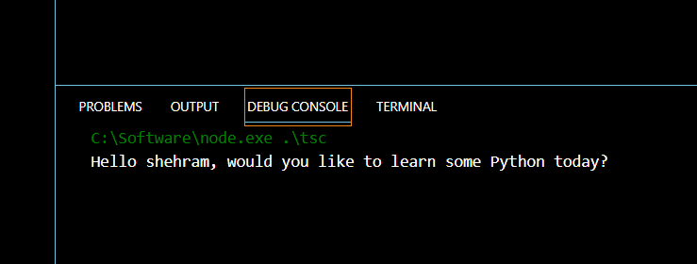 **Task 3:**

"use strict";

var personname="shehram";

console.log(personname.toUpperCase());

console.log(personname.toLowerCase());

console.log("Titlecase: "+ toTitleCase(personname));

function toTitleCase() {

    return ("Shehram Ali");

  }

